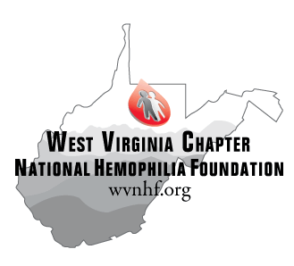
West Virginia Chapter of the National Hemophilia Foundation
Emergency Assistance Fund

Purpose:
The WVNHF Emergency Assistance Fund (EAF) is available to help families and individuals in the bleeding disorders community in unusual, one-time, emergency situations. It is set up to provide a one-time financial assistance grant (up to $500/year) to get a family through a crisis. It is not intended to be a repeat yearly fund. It is supported by generous contributions from individuals and corporations committed to the bleeding disorders community. Examples of appropriate grants are for food, utility bills, transportation to treatment, car repairs, rent support, medical supplies not covered by insurance, etc. The funds may be used for one time aid, which will significantly improve the applicant’s quality of life. The fund is not meant to be used to remedy chronic financial problems, nor does it apply to insurance or mortgage payments, or drugs and factor supplies.

Process:
Anyone with a bleeding disorder who resides within the state of West Virginia and has an emergency need, can apply to WVNHF’s Emergency Assistance Fund by filling out the “Application For Emergency Financial Assistance.” The Chapter will work with the hemophilia treatment centers and their affiliated social workers to determine who is most in need of these limited emergency funds. These individuals usually know the candidates, understand their current financial state, and are better suited to determine the severity of the need for emergency funds.

Guidelines:
- Assistance may be given once per year per individual.
- The maximum grant is $500.00. Larger amounts may be granted in special situations.
- The funds are not automatic, and must go through a rigorous review process by the Chapter with assistance from the HTC.
- WVNHF seeks to assure that its limited funds are used for true emergencies, and not regular, ongoing financial needs. Requests can be denied due to lack of funds or budgetary constraints.
- Emergency fund checks will be written from the Chapter to the creditor or vendor (i.e. Phone Company, Gas Company, landlord) and not directly to the consumer. This assures the funds are used properly.
- Treatment center staff may make requests anonymously to preserve patient confidentially. HTC staff should always inform the patient that funds have come from WVNHF’s Emergency Assistance Fund.
- Persons making the request must provide copies of bills or invoices or other documentation regarding the request. Funds will only be released for a specific, known emergency need.
- All requests for funding must be approved by the Chapter Executive Director and the Chapter Board of Directors.
- All requests for funding will be responded to within 3 days.

Questions:
Please contact the WVNHF office at 681-212-9255 or at atichnell@hemophilia.org.

03/2016

